PHASE 3
Project Design

System Architecture Diagram
The AI Fit Track API follows the MVC (Model-View-Controller) pattern to decouple business logic from data management. The Controller layer orchestrates workout logging, statistics aggregation, and AI insight generation via Gemini, while the Model layer manages User and WorkoutLog entities.
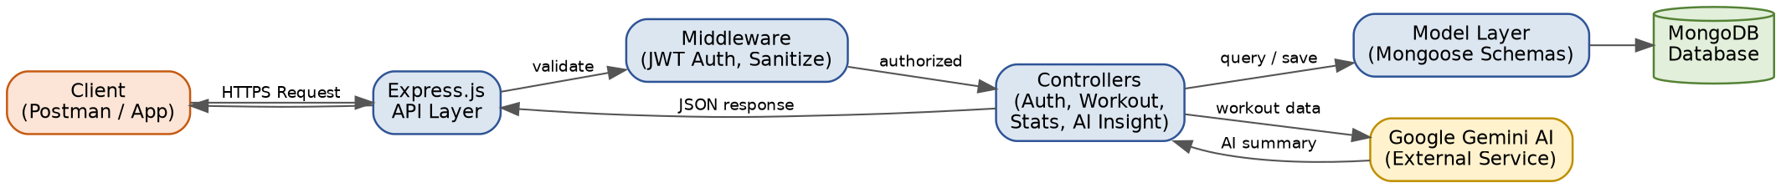
Fig 3.1 — Technical Architecture Diagram of the AI Fit Track API (MVC structure)

MVC Architecture Pattern
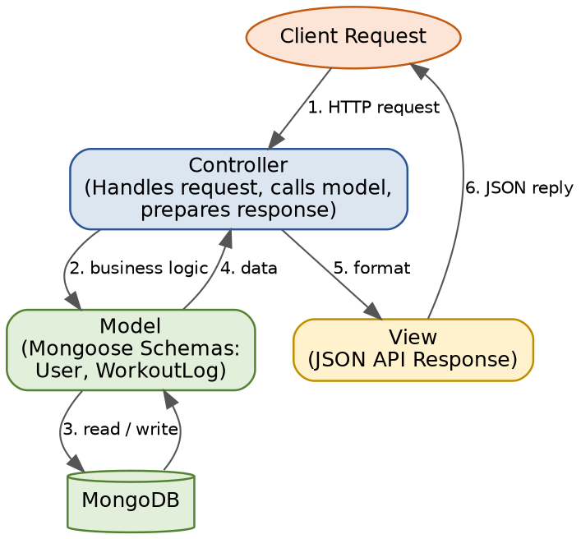
Fig 3.2 — Model-View-Controller architecture pattern used in the backend
Model Layer: Defines structure blueprints via strongly enforced Mongoose schemas mapping explicit fields into raw collection items inside MongoDB.
Controller Layer: Captures request vectors from the routes, checks structural request constraints, delegates processing to models and services, and packages the resultant output into JSON responses.
View Layer: As a headless backend service, the interface layer lives as an API Routing Layer, linking network requests on specified paths directly to their controller handlers.

Flowchart
The following flowchart illustrates the sequential user flow through the AI Fit Track API, from authentication to receiving AI-driven fitness insights.
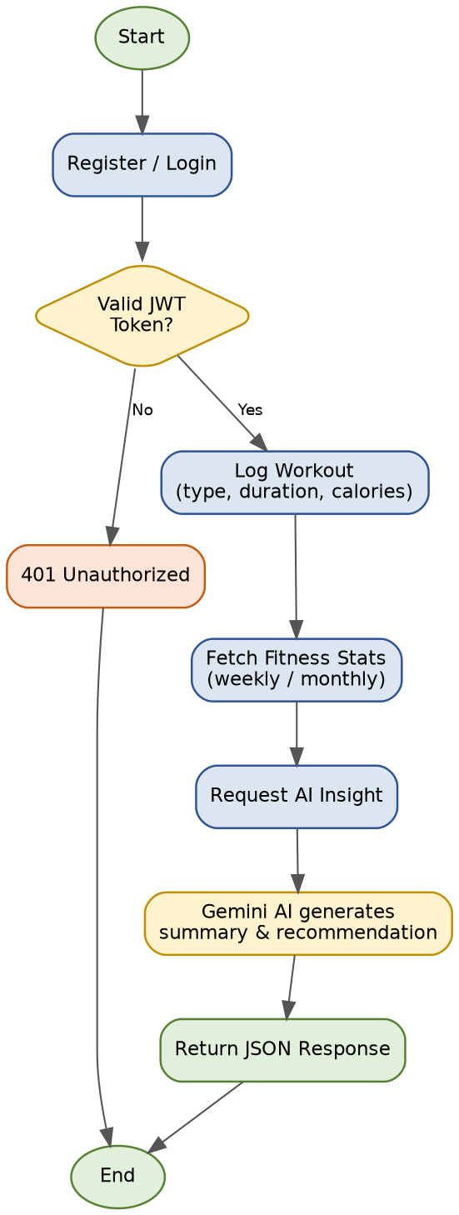
Fig 3.3 — User flow flowchart for the AI Fit Track API

ER Diagram / Database Design
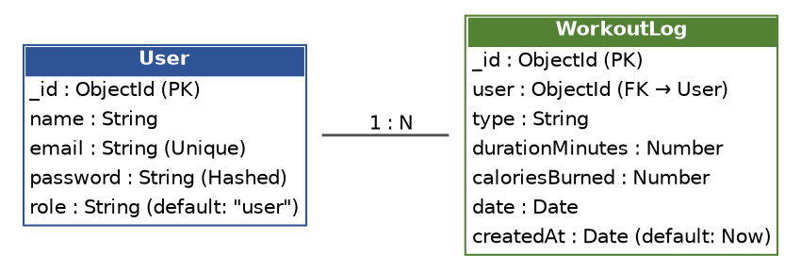
Fig 3.4 — Entity-Relationship diagram of User and WorkoutLog collections

User Entity
- _id — Primary Key (ObjectId)
- name — String, Required
- email — String, Required, Unique
- password — String, Hashed, Required
- role — String, Default: "user"

WorkoutLog Entity
- _id — Primary Key (ObjectId)
- user — Foreign Key referencing User collection
- type — String, Required (e.g., running, cycling, yoga, strength training)
- durationMinutes — Number, Required
- caloriesBurned — Number
- date — Date, Required
- createdAt — Date, Default: Now
Key Structural Mapping: User to WorkoutLog is a One-to-Many relationship — a registered user can log multiple workout entries.

Module Structure
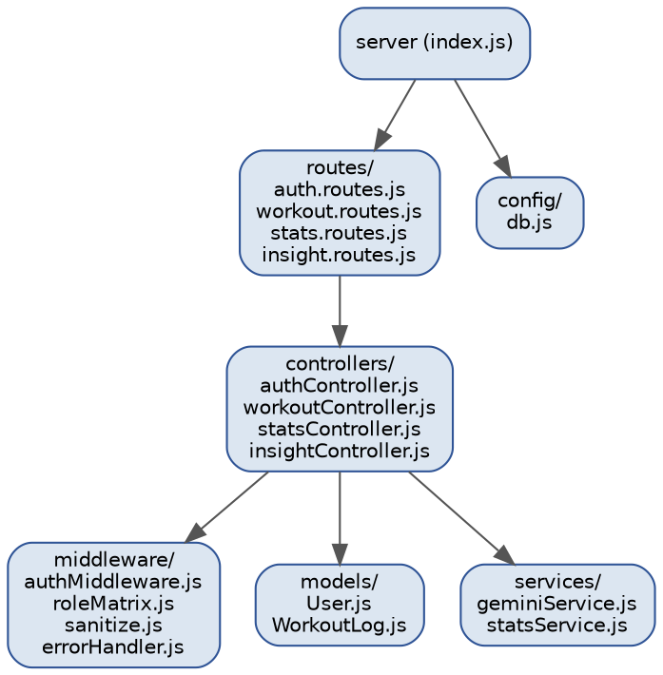
Fig 3.5 — Backend core structure / module implementation
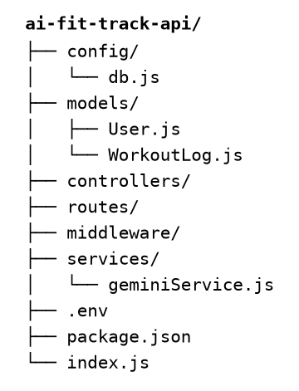
Fig 3.6 — Project folder structure
- Routing Layer — maps HTTP endpoints to controller functions.
- Controller Modules — Auth Controller, Workout Controller, Stats Controller, AI Insight Controller.
- Middleware — Authentication & Role Matrix Middleware, sanitization, centralized error handler.
- Model Layer — User schema and WorkoutLog schema (Mongoose).
- Service Layer — Fitness statistics aggregation service and Gemini AI integration service.

